**How to use the 5 Day Experience Pack**

**The 5 Day Experience Pack is mainly designed to help you try out the different flavors and see how you respond to each one. To really feel and see the benefits of using exogenous ketones, we recommend using for longer than 5 days. Because everyone is different and it is important you like the way it tastes, we offer this to help you decide what to order long term.**

**At the end of this document is an explanation of the differences in each of the flavors and what each one is designed to do.**

Some may think you are now beginning a ketogenic diet. It is important to understand you do not have to follow a ketogenic diet in order to use these. In fact, because following a ketogenic diet can be extremely difficult and take days to get into ketosis, these ketones are designed to put you in instant ketosis for only 41 calories. We encourage you to limit your starchy carbs/sweets so that the process will work even better.

For maximum results, taking KETO//OS on an empty stomach is ideal because in order for your body to use your fat stores as fuel, it has to first burn through the food you have already eaten. Although they are still beneficial for many other things besides fat loss and will work with food, if your goal is fat loss, taking on an empty stomach is recommended.

**Suggested Use:**

The most popular schedule is to take them when you first wake up. If you are a coffee drinker, we recommend coffee with Keto Kreme first. If you do not drink coffee, you can skip this step.

Then you would take your KETO//OS after your coffee settles. Consider starting with 1/2 a pack to see how you do and if you feel like it isn't working well, move up to a full pack.

The next step is to have your first meal when you begin to get hungry. A little hunger is okay, but when you start to get pretty hungry, go ahead and have your first meal. You will stay in ketosis until your first meal.

About 2-3 hours after you finish your first meal, take your second 1/2 or full pack of KETO//OS.

Eat again when you feel hungry.

Most people do not feel hungry at all while taking KETO and it helps them to avoid snacking, overeating, choosing unhealthy foods. This is fantastic, but we also want to make sure you are getting enough calories. You can figure your [**BMR requirements here**](http://www.bmi-calculator.net/bmr-calculator/)if you are overweight, then consider inputting your ideal/realistic weight you wish to achieve to get a more accurate BMR.

A great way to know naturally if you are eating enough is that if you find yourself very hungry at night or wake up at night hungry, or have a hard time controlling hunger the next day, your body is most likely overcompensating from not enough calories the previous day. Make adjustments as needed.

**If you are an athlete using KETO//OS,** we recommend taking 1/2 to a full packet 30 minutes prior to your workouts.

**For elderly and children who are using KETO for brain fuel**, the ketones can be added to their normal daily diet, added to smoothies, or however they would enjoy taking them. Ketones can be heated or frozen so making popcicles out of them and we even have a gummy candy recipe that can be made to serve them.

**Side Effects:**

Anytime you change what is going on in your body, there can sometimes be side effects. For example, when you go from an unhealthy diet to a healthy diet, some experience digestion problems, even though the food is healthy, because their body is adjusting to less junk, and their body is getting used to all the added nutrition.

1.) Supplementing with KETO//OS or following a ketogenic diet can cause a slightly diuretic effect, and can deplete magnesium, potassium and sodium stores. This can be rectified by supplementing with a good electrolyte like [Amped Hydrate](http://www.fitbyfaithfitness.isagenix.com/en-US/products/categories/individual-items/amped-hydrate) or increasing the sodium in your diet. However KETO//OS adds additional sodium to the formulation to counter-act this sodium depletion. The first signs of dehydration are fatigue, headache, dizziness, dry mouth, swollen tongue, constipation, possible elevation of blood pressure, palpitations or muscle cramping. If this occurs, decrease your serving size of Uncharged Keto//OS or drink plenty of water.

2.) KETO//OS 2.1 Orange Dream (Chocolate Swirl 3.0 & MAX do not have MCT) and Keto Kreme is blended with medium chain triglycerides, which can often times cause digestive distress. This is due to the fact that your body has not yet adapted to the increased fats in your diet, and is less efficient at utilizing ketones as its fuel source. Once the body has adapted to this increased fat in the diet, the digestive distress should resolve. We recommend to start slowly with a reduced serving size and build up to a full serving twice a day, but it is totally up to the individual. If diarrhea, stomach cramping or constipation occur, reduce your serving size of Keto//OS and/or consume Keto//OS with food (fat or protein) until bowel movements have returned to normal. Do not increase Keto//OS if you are experience digestive stress. Please make sure that you are drinking enough water and taking a multi-mineral supplement or an/ electrolyte like [Amped Hydrate](http://www.fitbyfaithfitness.isagenix.com/en-US/products/categories/individual-items/amped-hydrate).

3.) Experiencing Diarrhea and cramping then decrease Keto//OS, drink slower (over 20-30minutes) and consume with food. This will slow down the absorption of the exogenous ketones. Do not increase Keto//OS until bowel movements have returned to normal and use the uncharged version.

4.) Experiencing constipation, reduce the servings size, drink slower (over 20-30minutes), take a magnesium/multi-mineral supplement and drink plenty of water. the major function of the large intestine is to reabsorb water. Do not increase Keto//OS until bowel movements have returned to normal.

On the next page, we have information on the difference in the 3 flavors of KETO//OS and also you will see information on the new flavor MAX Swiss Cacao coming out in April 2017.

If you would like to read an actual journal of a fitness trainer who used the products, you can read it here at <www.fitbyfaith.net/ketonejournal.html>

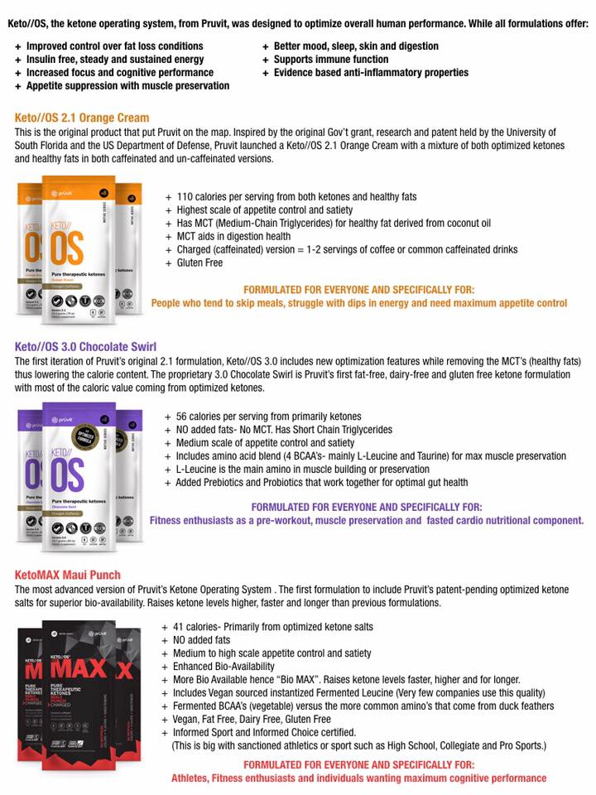

**Top of Form**

